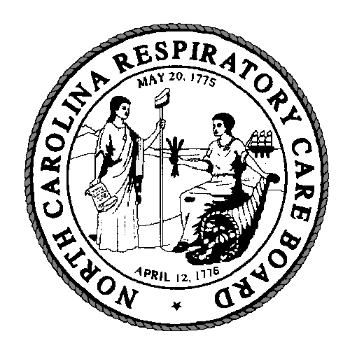
Summary of Changes

Modernize Respiratory Care Practice Act
House Bill 358

Submitted by: William L. Croft, PhD, RRT, RCP
William L. Croft, PhD, RRT, RCP
Executive Director
North Carolina Respiratory Care Board
(w) 919-878-5595
(c) 910-603-0136

Table of Contents

SECTION 1 / § 90-648. 3
SECTION 2 / § 90-649 and § 90-650. 5
SECTION 4 / § 90-652 6
SECTION 5 / § 90-653 7
SECTION 6-7 / § 90-654 , § 90-654, and § 90-660 9

SECTION 1 / § 90-648. Definitions.
[Pages 1-2 of the Bill]

# | Page/  Line | Text Change | Explanation
 | Page 1 line 7-8 | AMENDS THE DEFINITIONS for 90-648 BY ADDING PARAGRAPH (15) AS FOLLOWS:  “Advanced Practice- Procedures that require formal training by rules adopted pursuant to this Article”. | Since 2000 when the RCPA was passed, many procedures are deemed advanced practice and require greater levels of training. Adding this section allows the Board to write rules that would ensure the public safety when performing such activities. Licensees would be issued endorsements by the board (see above section) to ensure the licensee documents the training.
 | Page 1 line 11-13 | AMENDS THE DEFINITIONS for 90-648 BY ADDING PARAGRAPH (14) AS FOLLOWS:  “Endorsement - A certificate issued by the Board recognizing the person named therein as having met the requirements to perform respiratory care procedures as defined in this Article”. | This change is based on discussions of the Joint Legislative Administrative Procedure Oversight Committee to have one license and options added for endorsements to improve the efficiency of the Board. The recommendation was part of Senator Andy Well’s presentation.

 | Page 1  Lines 22-23 | AMENDS SUBPART (a) TO THE DEFINITION OF PRACTICE OF RESPIRATORY CARE IN 90-648 (10) AS FOLLOWS:  “Medical gases, humidity, and aerosols including the use of associated respiratory care equipment, except for the purpose of anesthesia.” | Clarifies some activities that constitute the practice of respiratory care.
 | Page  2  Lines  9-15 | REVISES DEFINITION OF  “SUPPORT ACTIVITIES” THAT ARE EXEMPT IN 90-648 (13):  “The term “support activities” does not include evaluation or assessment of the therapeutic effectiveness of any respiratory care treatment or respiratory care equipment for an individual patient.” | Clarifies the definition of Support Activities for which no respiratory care license is required.

SECTION 2 and 3 / § 90-649 and 90-650. Board Creation and Appointments and removal of Board members; terms and compensation.
[Pages 2 of the Bill]
5. | Page 2 Lines  16-19 | AMENDS SUBPART (a) (4) of § 90 649 board creation to read” “one North Carolina member shall represent the Atlantic Coast Medical Equipment Services Association. | The organization had a name change and are now part of a two state association between NC and SC. This section would require a NC member be appointed.
6. | Page 2 Lines  21-23 | AMENDS SUBPART (a) (7) of § 90 650 board creation to read” “The Atlantic Coast Medical Equipment Services Association shall appoint the member described in G.S. 90-649 (a)(4) | The organization had a name change and are now part of a two state association between NC and SC.

SECTION 4 / § 90-652. Powers and duties of the

Board.

[Pages 2-3 of the Bill]

# | Page/  Line | Text | Explanation
7. | Page  2  Lines  31-39 | DELETES PART OF 90-652 (1) | This removes language that is no longer required by the N.C. Department of Justice in order for a licensing board to have access to criminal background checks.
8. | Page  3  Lines  1-2 | ADDS 90-652 (14):  “Establish and adopt rules defining the education and credential requirements for persons seeking endorsement under this Article”. | This allows the Board to adopt rules to define the requirements for the endorsement requirements as added in page 2 lines 14-16

SECTION 5 / § 90-653. Licensure requirements; examination.

[Pages 3 of the Bill]

# | Page/  Line(s) | Text | Explanation
 | Page  3  Lines  5-6 | REVISES THE WORDING OF 90-653(a) | Technical change.
 | Page  3  Lines  7-10 | ADDS THE FOLLOWING TO 90-653(a)(1):  “including a form signed by the applicant consenting to the check of the applicant’s criminal record and to the use of the applicant’s fingerprints and other identifying information required by the State and national repositories.” | Clarifies that to receive a license, an applicant must to sign a form to authorize fingerprinting.
 | Page  3  Lines  12-19 | AMENDS 90-653(a)(3) WITH REFERENCE TO THE REQUIRED EDUCATION | Updates the references to pertinent educational requirements. Clarifies language for accrediting agency and states the degree requirements in place since 2000. Allows electronic transcripts to be sent to the board to expedite the licensing process.
 | Page  3  Line  24-26 | AMENDS 90-653(a)(5) WITH REFERENCE TO EXAMINATION REQUIREMENTS:  “Submit to the Board written evidence, verified by oath, that the applicant passed the Therapist Multiple-Choice (TMC) examination given by the National Board for Respiratory Care, Inc or its successor”. | Denotes a technical name change by the NBRC for the required exam. It does not impact any of the current licensees. Requires applicants submit written evidence that they have passed the national TMC examination rather than the entry level exam since all person passing the exam are eligible for licensing.
 | Page  3  Lines  27-30 | Deletes 90-653(b). | The national examination may be taken any time during the week at multiple North Carolina locations through H and R Block Testing centers, so this language is not needed.
 | Page  3  Lines 31-32 | ADDS 90-653(b1):  “When issuing a license, the Board shall state the terms and conditions of use of the license to the licensee.” | Clarifies that the terms and conditions of the license are mandated by the Board.

SECTION 6 and 7 / § 90-654, § 90-654, and § 90-660. Provisional and Temporary License.

[Page 3 of the Bill]

# | Page/  Line | Text | Explanation
 | Page  3  Lines 34 | DELETES LANGUAGE 90-660 (b) (6) FOR TEMPORARY AND PROVISIONAL LICENSE. | Technical change.
 | Page  3  Lines 36 | REPEALS 90-654 and 90-656 WITH REFERENCE TO REQUIREMENTS FOR A TEMPORARY AND PROVISIONAL LICENSE. | This change is based on discussions of the Joint Legislative Administrative Procedure Oversight Committee to have one license and options added for endorsements.  Adding the endorsements definitions Section 1 and 2 allows the Board to adopt rules to define the temporary and provisional licensing requirements which will include rules for an temporary license for military.

